What is GitHub
GitHub is a Git repository hosting service. GitHub also facilitates with many of its features, such as access control and collaboration. It provides a Web-based graphical interface.
GitHub is an American company. It hosts source code of your project in the form of different programming languages and keeps track of the various changes made by programmers.
It offers both distributed version control and source code management (SCM) functionality of Git. It also facilitates with some collaboration features such as bug tracking, feature requests, task management for every project.
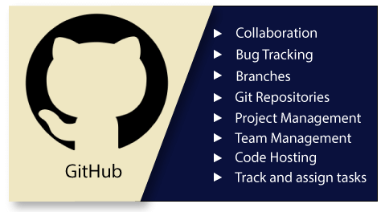

Features of GitHub
GitHub is a place where programmers and designers work together. They collaborate, contribute, and fix bugs together. It hosts plenty of open source projects and codes of various programming languages.
Some of its significant features are as follows.
- Collaboration
- Integrated issue and bug tracking
- Graphical representation of branches
- Git repositories hosting
- Project management
- Team management
- Code hosting
- Track and assign tasks
- Conversations
- Wikisc

Benefits of GitHub
GitHub can be separated as the Git and the Hub. GitHub service includes access controls as well as collaboration features like task management, repository hosting, and team management.
The key benefits of GitHub are as follows.
- It is easy to contribute to open source projects via GitHub.
- It helps to create an excellent document.
- You can attract recruiter by showing off your work. If you have a profile on GitHub, you will have a higher chance of being recruited.
- It allows your work to get out there in front of the public.
- You can track changes in your code across versions.

